## Motor Mounting:

Option 1 – Angled mount (adjustable) with motor facing downwards, hole in the floor with a bearing: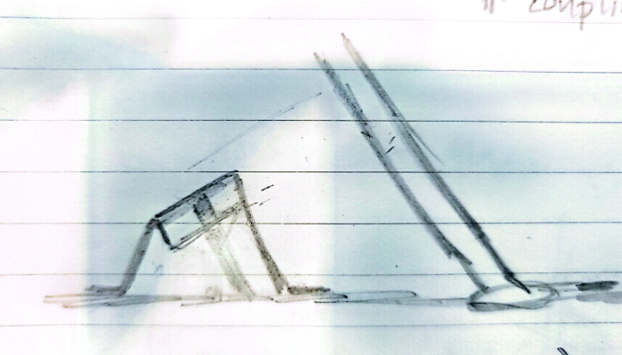

Option 2: Parallel mount (adjustable), motor facing downwards, U-joint with bearing (Information, despite the detail presented on the sketch below, it is important to note that the motor will be mounted atop the base mount)  
  
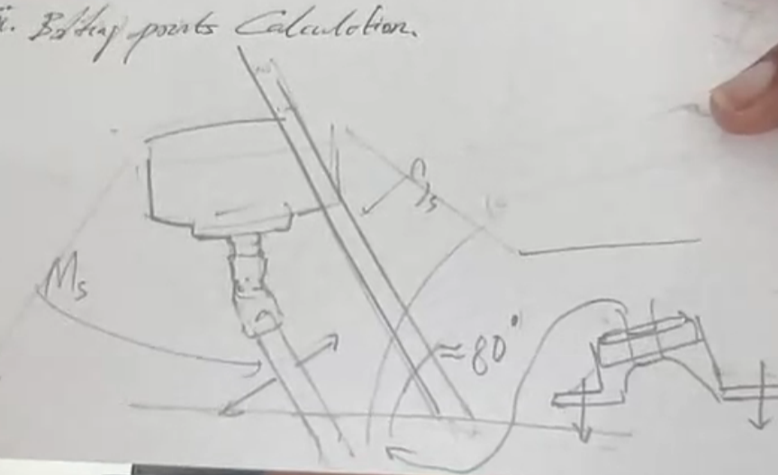

Option 3: Angled mount (adjustable) motor facing upwards.

## **Adjustable Mechanism:**

**Option 1:**

**Option 2:**

**Option 3:**